SIMATS ENGINEERING
CONTINOUS INTERNAL ASSESSMENT- CONCEPT MAPPING
COURSE NAME: DATABASE MANAGEMENT SYSTEMS COURSE CODE:

COURSE OUTCOME COVERED
COI: Analyze DBMS architecture, different data models, schema types, and design ERIEER diagrams, relational schemas for case-based scenarios by identifying entities and relationships.
(BLI, BL2)

Questions:05 Total marks: 100
Annexure A
CONCEPT MAPPING

Cod%0f Conduct:

(192571060)
I API (Name / Reg No) certify that this submission is my original work and that I have adhered to the guidelines specified for this assessment.
I understand that any violation of academic integrity rules will result in disciplinary action.
Signature of the student:
ANNEXURE
CONCEPT MAPPI ^{N}G
QUESTIONS
Q.NO Question
Bloom's Level
A university database contains Persons, Students, Faculty, and Staff, where specialized entitles inherit common properties from a general
- entity. Explain how the EER model extends the basic ER model using B1.2 Understand generalization, specialization, and aggregation. Construct a concept map illustrating these concepts and their relationships.
An online banking application receives a user's request to rctncve account information. Construct a visual concept map explaining the
- flow of the request through the DBMS software architecture, BI-2 Urdcrstand including the query processor, transaction manager, storage manager, database files, and data retrieval process.
Different organizations use different data models according to their requirements. Constillct a concept map connecting Hierarchical,
- Network, Relational, and ER/EER models with suitable real-world BL2 — Understand applications such as organizational systems, transportation networks, banking systems, and university databases. Explain the suitability of each model.
A university database undergoes changes in its logical structure and physical storage without changing how users access the data.

- Construct a concept map explaining schema, instance, logical BE -Understand schema, physical schema, logical data independence, and physical data independence, and show the relationship among these concepts.
An organization uses a DBMS to manage its business data. Construct a concept map showing the roles of the Database Administrator
Developer. Include their major BLI — Remember

- (DBA), End User, and Application responsibilities and explain how they interact within the overall DBMS environment.



CONccvr MapplNG

FER Mod/ -
Pegon
Common AntFrìBu±Lå : Narvt0)
8PQc-ì n
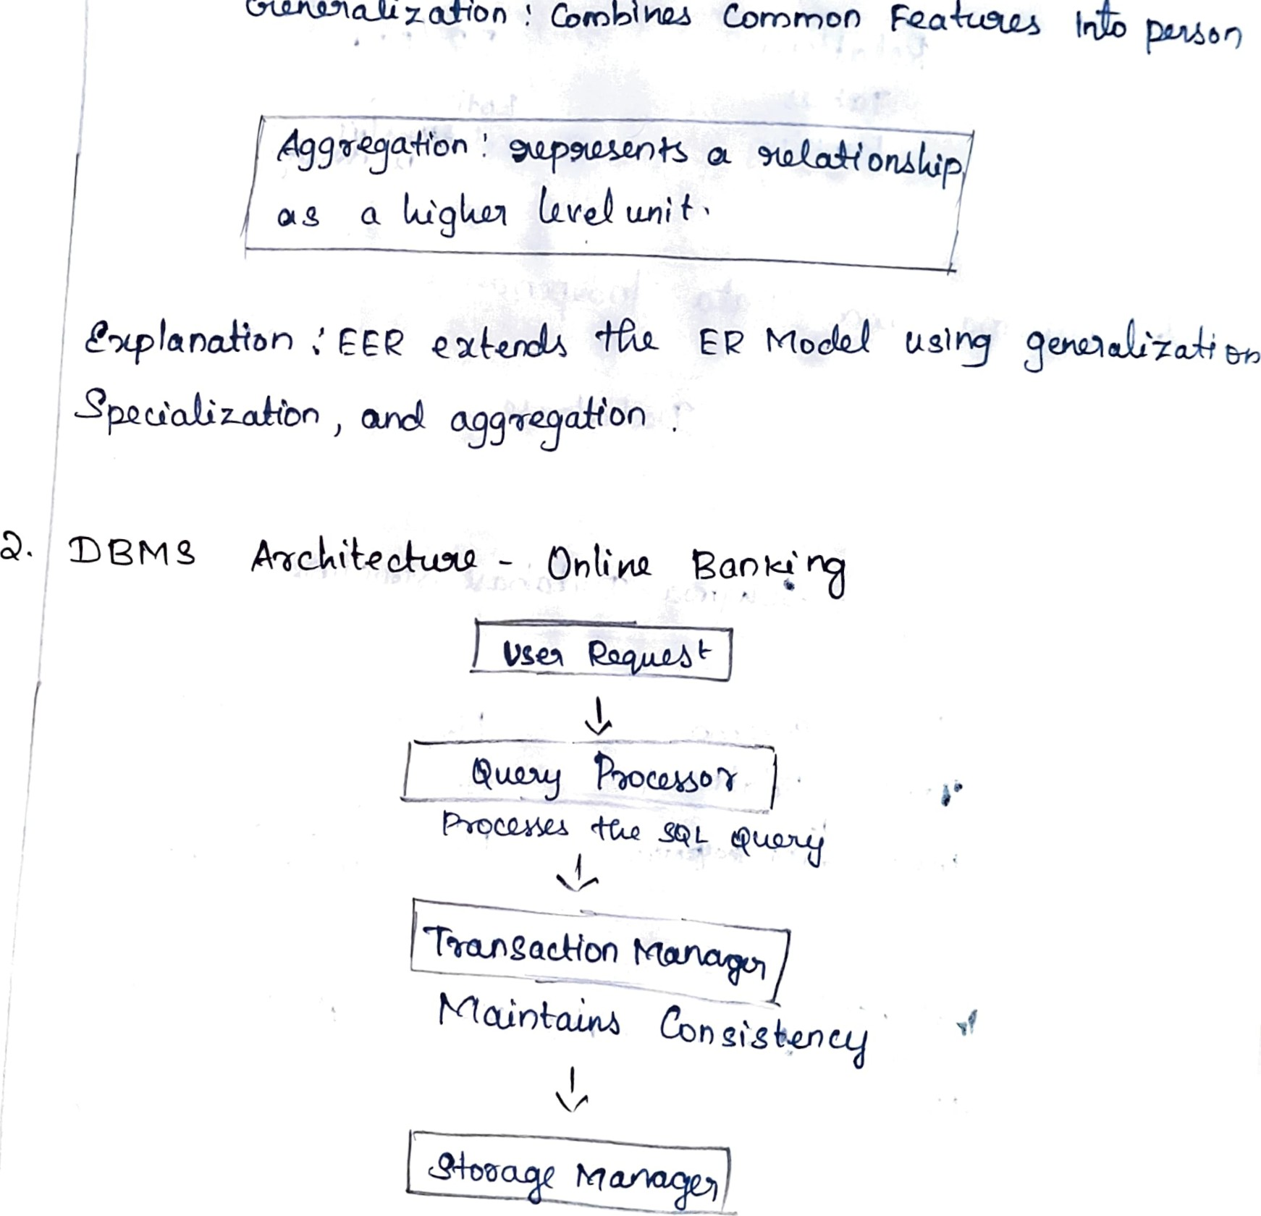
&-uu-na--lìzoffl0n
CocobihQJ
Common
FQake_LS
,


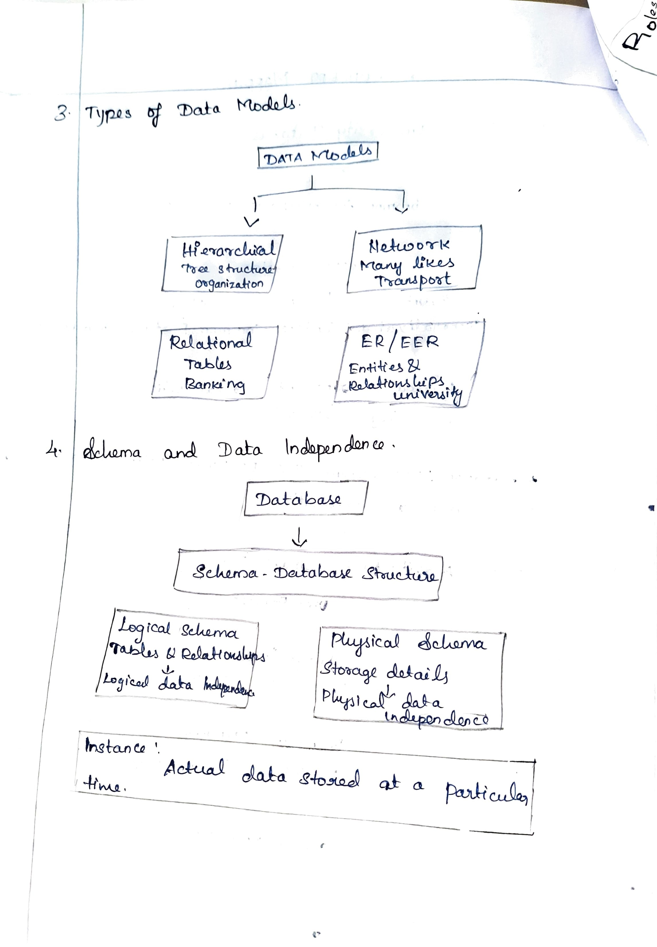

DBMg 
